**Name Date Pd.**

**Drugs, Poisons, and Alcohol Review**

*This will be collected on the day of the test.*

1. What is forensic toxicology?
2. What does a toxicologist do?
3. Which is more common: poisoning murder or accidental drug overdose?
4. What is a drug?
5. Name the five classes of drugs and write a brief description of how the drug works and the overdose symptoms for that drug.

a.

b.

c.

d.

e.

1. Summarize the federal laws about marijuana. Summarize the Maryland laws. What is the Department of Justice’s policy on marijuana enforcement?
2. What does “Schedule” mean, in terms of Federal drug law? Describe the five different schedules.
3. What is the difference between a screening test and a confirmational test for drugs?
4. List the five screening tests—the name, what they test for, and the expected color change.

a.

b.

c.

d.

e.

1. Give an example of a confirmational test for drugs. Is this class or individual evidence?
2. Explain how to package up a sample of drugs found at a crime scene.
3. What is LD50? Why is it a useful concept in the study of poisons?
4. “The dose makes the poison.” Explain this quotation and its application the study of poisons.
5. Who were Alexander Gettler and Charles Norris? What were their contributions to forensic science?
6. List the eight poisons discussed in “The Poisoner’s Handbook.”
7. Cyanide—name the test used to detect it and symptoms of poisoning.
8. Arsenic—name the test used to detect it and symptoms of poisoning.
9. Describe the symptoms of poisoning for lead, carbon monoxide, radium, and thallium.
10. What is the chemical name for alcohol?
11. Describe the three stages as alcohol passes through the body.
12. What are some factors that affect how quickly alcohol is absorbed?

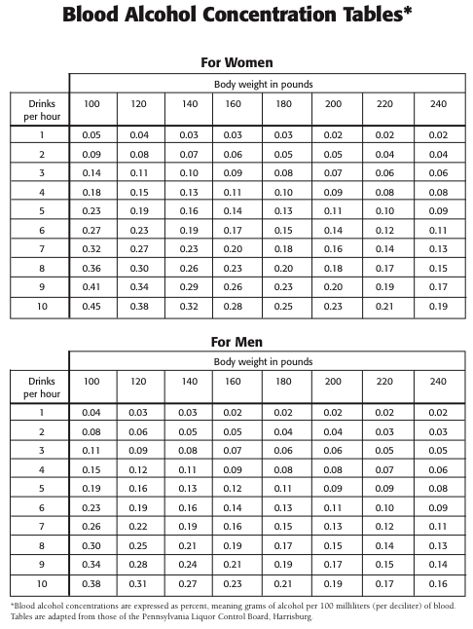

1. How does a breathalyzer work?
2. What are the three field sobriety tests?
3. What are Maryland’s DUI laws?
4. What is the BAC of a 140 lb man who has drunk two drinks an hour for three hours? Assume this is at the end of the third hour. If he is over 21, can he legally drive?